

MSc. Computer Science
BIG DATA AND BUSINESS INTELLIGENCE

Name:
Student ID:

Contents
1. Executive Summary 4
2. Data Source Description 6
2.1. Introduction 6
2.2. Data Source: 7
2.3. BI Requirements and Questions: 8
3. Fining based on analysis and evaluation. 11
4. Conclusions and Recommendations 27
1. Data preprocessing or Data Cleansing 32
2. BI Data Modelling via Star Schema – Facts and Dimensions. 37
3. DAX Functions and Calculated Columns 42
4. Dashboards 48
4.1. Welcome Dashboard 48
4.2. Crime Analysis by Type 49
4.3. Crime Trends Over Time 50
4.4. Victim Demographics 51
4.5. Case Status and Police Response 52

SECTION 1: BUSINESS INTELLIGENCE REPORT

Executive Summary
This report offers a thorough examination of crime statistics via the use of a Business Intelligence (BI) solution created using Power BI. This solution aims to provide insights that can help law enforcement organizations better allocate resources, prevent crime, and resolve cases. A simple method for visualizing trends, spotting patterns, and assisting in decision-making is provided by this BI dashboard.
Key insights from the analysis include:
- Crime Trends: The reported crime rate is 30% closed, and crime rates tend to increase in the summer. With over two-thirds of all recorded crimes being theft and violence, these are the most prevalent offences.
- Victim Demographics: Most violent crimes, particularly in metropolitan areas, disproportionately harm males and younger people (ages 18 to 30).
- Geospatial Analysis: Urban areas have a high crime density; the cities with the highest crime rates include Delhi, Mumbai, and Bangalore. These cities are hotspots where concentrated criminal activity necessitates focused law enforcement measures.
- Allocation of Resources: Although police presence is correlated with crime patterns, proactive measures would be advantageous, particularly during periods of high crime.
Recommendations:
- In order to combat the growing crime rates during the summer, implement seasonal programs.
- To increase closure rates, give theft and assault cases more attention.
- Create regulations aimed at high-crime metropolitan regions.
- Launch youth-focused awareness campaigns to lessen the susceptibility of those in the 18–30 age range.
The following visuals summarize key findings:
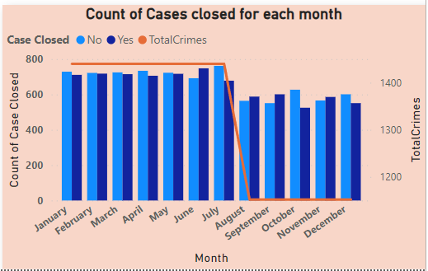
A combination chart showcasing the monthly breakdown of cases closed (categorized as "Yes" or "No") alongside the trend of total crimes reported.
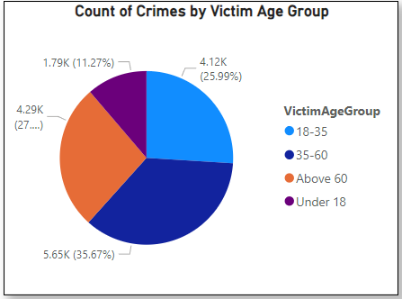
A pie chart displaying the percentage distribution of crimes across different victim age groups, emphasizing the 18-35 age group as the most affected.
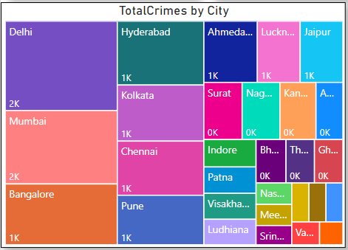
A treemap visualization highlighting the volume of crimes in various cities, with Delhi, Mumbai, and Bangalore exhibiting the highest numbers.

Data Source Description

Introduction
This dataset on criminal activities includes incidents reported from different cities in India and records crucial information like the nature of the crime, its location, date and time, victim profiles, weapon employed, police presence, and the status of case resolution. Examining this data is crucial in discerning high-risk regions and prevalent crime categories, comprehending the variables influencing case closure rates, enhancing police resource distribution, and formulating precise victim assistance and prevention tactics. It is imperative to utilize tools such as Power BI for the visualization of crime data, as it enables stakeholders to promptly identify patterns, monitor trends, and render data-informed decisions to bolster public safety and enhance the efficiency of law enforcement. Organizations can tackle urgent challenges in crime management and establish more efficient and responsive safety measures for communities by utilizing this dataset.

Data Source:
Let's look at the Crime data in India analysis report. The objective of this report shall be to give an overall picture of this analysis is to gain insights into crime patterns. The crime data set is taken from the year duration of 2020 - 2024.The source link of the dataset is: https://www.kaggle.com/datasets/sudhanvahg/indian-crimes-dataset
This dataset provides an extensive overview of criminal activities across various Indian cities from 2020 to 2024. It contains detailed information on crime types, occurrence dates and times, weapons involved, victim demographics, and police deployment levels. Covering a wide range of offenses, from identity theft to homicide, the dataset offers valuable insights for researchers, policymakers, and law enforcement agencies seeking to understand crime trends and enhance public safety. Additionally, it includes data on case resolutions, offering a clear picture of crime closure rates across cities.
This dataset comprises a singular table featuring 14 columns, encompassing strings (08), date and time (01), and integers (04). The following is a precise elucidation of the data.
Explanation of Columns:
- Report Number: Unique identifier for the report.
- Date Reported: The date the crime report was filed.
- Date of Occurrence: The date the crime took place.
- Time of Occurrence: The time the crime occurred.
- City: The city where the crime occurred.
- Crime Code: A numerical code used to classify the type of crime.
- Crime Description: A brief description of the crime.
- Victim Age: The age of the victim involved in the crime.
- Victim Gender: The gender of the victim.
- Weapon Used: The weapon involved in the crime, if any.
- Crime Domain: Classification of the crime (e.g., violent crime, property crime).
- Police Deployed: The number of officers sent to handle the crime.
- Case Closed: Whether or not the case has been closed (Yes/No).
- Date Case Closed: The date the case was closed, if applicable
The source of dataset for analysis:
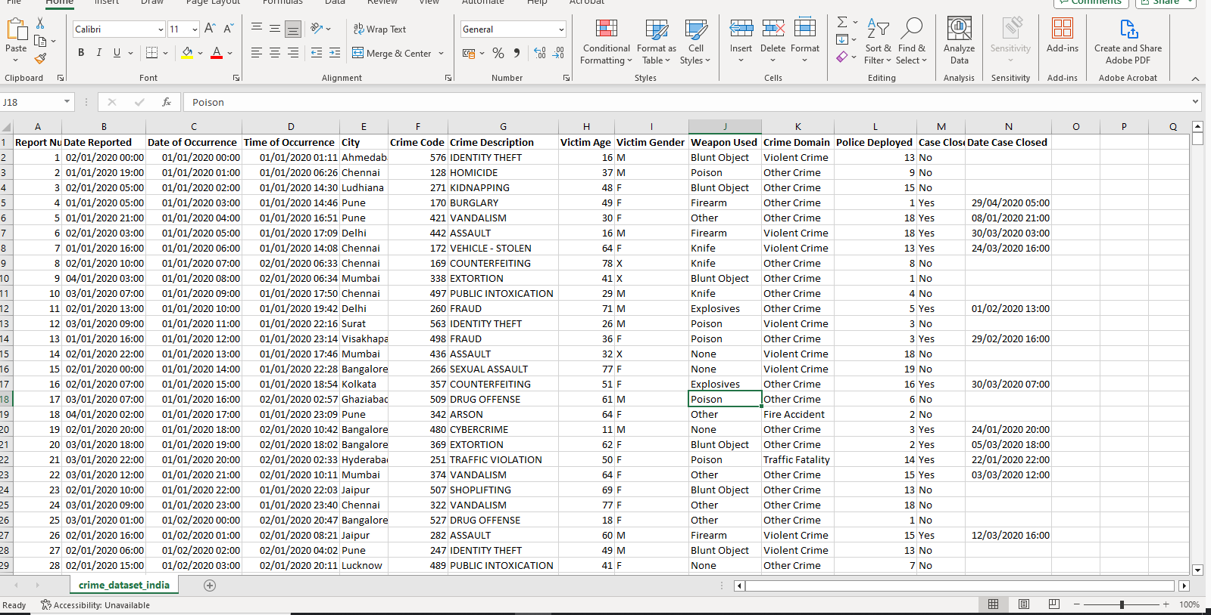
Crime in India – 2020 - 24

BI Requirements and Questions:

KPI - What business processes are critical to measure?

- Rate of Crime Resolution:
- calculating the proportion of reported instances that are successfully resolved, which offers information on how effective law enforcement is.
- Determining patterns in case closure rates over time in order to assess the effects of changes to procedures, policy, or resource allocation.
- Examining case resolution times in various criminal sectors to find inefficiencies or bottlenecks.
- Crime Trends by Victim Demographics, Domain, and City:

- To determine which kinds of crimes are most common, the frequency of crimes in different domains (such as violent crime, road deaths, and fire accidents) should be monitored.
- By identifying regional crime hotspots by geographic analysis of crime by city, targeted actions are made possible.
- Victims' age and gender are analyzed to determine which groups are most at risk, enabling the development of preventative measures and targeted awareness campaigns.
- Efficiency of Police Resource Allocation:

- Assessing the distribution of police resources throughout cities and crime domains to make sure that high-crime regions receive the best possible allocation.
- Examining the relationship between police presence and crime resolution rates in order to evaluate how well resource allocation plans are working.
- Measuring the amount of police resources used for each type of crime in order to pinpoint areas that could be over- or under-resourced.

What Questions/Problems are Being Solved?

- How can we improve decision-making and public safety by analyzing crime trends, case resolution effectiveness, and resource allocation across various domains, cities, and time periods?
- What is the distribution of crimes across different domains, and which crime domain contributes the most to the overall crime rate?
- How has the total number of crimes changed over the years, and are there any significant trends or anomalies in yearly crime patterns?
- What are the overall crime statistics, including total reported crimes, average resolution time, police deployment, and case closure percentage, and how do these metrics reflect the efficiency of law enforcement?
- Which cities report the highest crime volumes, and how does the crime distribution vary across different regions?
- How can the trends, distributions, and case outcomes of different crime types across cities, domains, and years help identify key hotspots, improve resource allocation, and enhance case resolution strategies?
  - How have the reported cases for different crime types evolved annualy from 2020 to 2024, and what trends or patterns can be identified across these years?
  - What is the distribution of crimes across specific descriptions and domains, and which crime descriptions are most prevalent within each domain?
  - How have the total crimes in each domain fluctuated annually, and which domains show increasing, decreasing, or stable trends over the years?
  - What is the distribution of total crimes across different domains, and how does the case closure rate vary within each domain?
- What are the temporal trends and seasonal patterns in crime occurrences across different domains and cities, and how do police deployments and case closures vary over time?
  - How have total crime occurrences varied over the years across different crime domains?
  - What is the annual trend in total reported crimes over the years?
  - What is the relationship between the total police deployed and the crime code count across different crime domains?
  - Which cities have the highest and lowest number of cases closed, and how do they compare across all reported cities?
  - How have different crime descriptions trended over the years, and which categories show significant increases or decreases?
- How do victim demographics, such as age and gender, correlate with crime types and case resolutions?
  - What is the age distribution of victims for each crime type, and how does it vary across different crime descriptions?
  - What is the distribution of crimes across different victim age groups, and which age group experiences the highest crime incidence?
  - How does the number of closed cases vary across different victim age groups, and which group has the highest case resolution rate?
  - How do total reported cases vary by age groups across different crime domains, and which domain has the highest occurrence for each age group?
- How efficiently are police resources being deployed across different crime domains, and how does this impact case closure rates and time to resolution?
  - How does the allocation of police resources vary by victim gender across different crime domains?
  - How are police resources allocated across different crime domains?
Key User Groups:
- Law Enforcement Organizations:
- The main users in charge of looking into and fixing offences.
- To increase operational efficiency, comprehensive insights into crime patterns, resource allocation, and performance measures are required.
- Determine high-crime regions using the data, then strategically allocate resources to prevent and resolve crimes.
- Decision-makers:
- To develop policies that lower crime and improve public safety, a macro-level understanding of crime trends is necessary.
- Funding for police forces and victim protection programs may be allocated using insights.
- Create and implement legislation based on data-driven proof of the frequency of crimes and their resolution rates.
- Advocacy Groups for Victims:
- In order to support vulnerable groups and give victims targeted aid, demographic insights are required.
- Make use of the information to support the provision of more funds to particular areas or domains with high victimization rates.
- Create campaigns and activities to raise community awareness based on crime trends and impacted populations.
- Researchers and Analysts:
- Make use of the information to identify long-term trends and patterns in crime across demographic groups and geographical areas.
- Offer analysis and suggestions for enhancing resource efficiency and crime prevention tactics.
- Encourage stakeholders at different levels to make decisions based on data.
Why Is This Information Needed?
- To lower crime rates:
- Authorities can take proactive steps to stop crimes before they happen by spotting trends in crime patterns.
- Targeted interventions that target the most impacted areas and people are made possible by demographic and geographic knowledge.
- To improve public safety:
- Communities become safer when trends are tracked, and crime hotspots are addressed.
- Providing targeted protective measures to victims and vulnerable groups increases public trust in law enforcement.
- To Distribute Resources Efficiently:
- By ensuring that police resources are directed where they are most needed, a data-driven strategy minimises resource waste and enhances results.
- assists in identifying and prioritising underperforming domains or areas for process enhancements and resource reallocation.
- To Increase the Rate of Case Resolution:
- By highlighting areas for improvement, case closure rate analysis helps law enforcement agencies optimise their processes and provide better training.
- A quicker case settlement process guarantees victims' justice and fosters public trust.

Fining based on analysis and evaluation.
Through analysis and visualizations, the insights obtained from the Power BI dashboards are compiled in this area. Every figure has been created to offer practical insights on victim demographics, resource allocation, and crime patterns. The results and descriptions of each graphic are shown below.
- How can we improve decision-making and public safety by analyzing crime trends, case resolution effectiveness, and resource allocation across various domains, cities, and time periods?

- What is the distribution of crimes across different domains, and which crime domain contributes the most to the overall crime rate?

- Count of Crime Domain
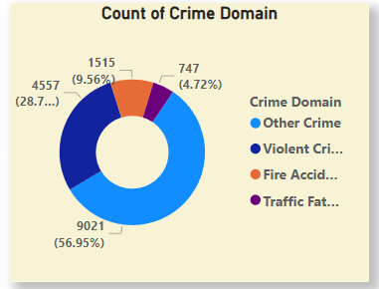
Visual Type: Donut Chart

Description: This chart depicts the distribution of crimes across four domains: Other Crimes, Violent Crimes, Fire Accidents, and Traffic Fatalities, showing the proportional contribution of each.
Key Findings: Other Crimes constitute the majority (56.95%), followed by Violent Crimes (28.7%). Fire Accidents and Traffic Fatalities have the lowest share at 9.56% and 4.72%, respectively, indicating these areas may require more targeted interventions despite their smaller proportion.

- How has the total number of crimes changed over the years, and are there any significant trends or anomalies in yearly crime patterns?
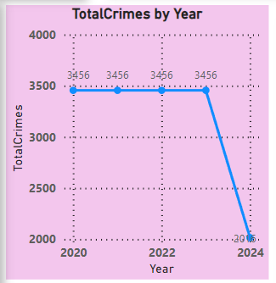
Visual Type: Line Chart

Description: This chart shows the annual trend of total reported crimes from 2020 to 2024, highlighting variations in crime volume over the years.

Key Findings: Total crimes remained stable at 3,456 from 2020 to 2023 but saw a sharp decline to 2,010 in 2024, suggesting a potential improvement in public safety or changes in reporting mechanisms.

- What are the overall crime statistics, including total reported crimes, average resolution time, police deployment, and case closure percentage, and how do these metrics reflect the efficiency of law enforcement?
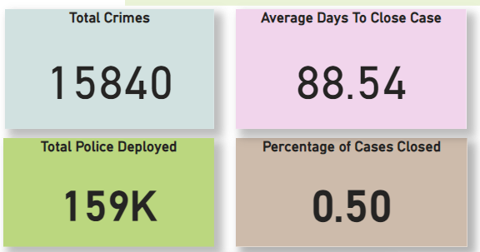
Visual Type: KPI Cards

Description: These KPIs summarize key metrics including total crimes, average days to close cases, total police deployed, and the percentage of cases closed.

Key Findings: A total of 15,840 crimes were reported, with an average case closure time of 88.54 days. While 159K police were deployed, only 50% of the cases have been closed, indicating room for improvement in efficiency and resource utilization.

- Which cities report the highest crime volumes, and how does the crime distribution vary across different regions?
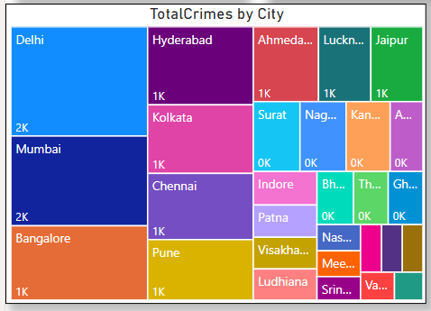
Visual Type: TreeMap
Description:
This is a Tree Map visual showcasing the total number of crimes reported in each city. Each city is represented by a rectangular block, with the size of the block indicating the relative number of crimes in that city.
Key Findings:
- Delhi, Mumbai, and Bangalore report the highest crime volumes compared to other cities, each accounting for over 2,000 crimes.
- Smaller cities like Lucknow, Ahmedabad, and Jaipur contribute significantly less to the overall crime count, with crime volumes of around 1,000 each.
- The visual highlights geographical disparities in crime reporting, emphasizing the need for targeted interventions in high-crime cities like Delhi and Mumbai.
- How can the trends, distributions, and case outcomes of different crime types across cities, domains, and years help identify key hotspots, improve resource allocation, and enhance case resolution strategies?
  - How have the reported cases for different crime types evolved annually from 2020 to 2024, and what trends or patterns can be identified across these years?
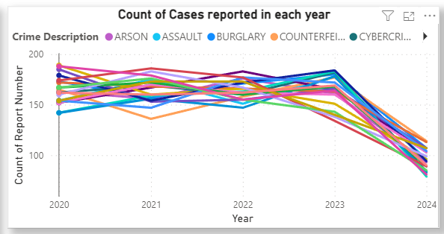
Visual Type: Line Chart

Description: This chart illustrates the yearly trend in the count of reported cases for various crime descriptions, providing a comparative view across different crime types.

Key Findings: Reported cases for most crime descriptions remained relatively stable from 2020 to 2023, with a noticeable decline in 2024. Cybercrimes, assault, and burglary exhibit consistent reporting levels, indicating persistent challenges in these areas.

  - What is the distribution of crimes across specific descriptions and domains, and which crime descriptions are most prevalent within each domain?
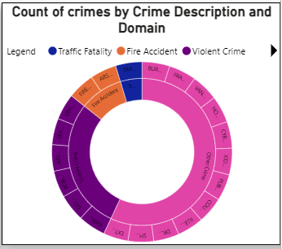
Visual Type: Donut Chart with Hierarchical Segmentation

Description: This chart shows the count of crimes categorized by crime domains (e.g., Violent Crime, Fire Accident, Traffic Fatality) and further breaks them down by specific crime descriptions.

Key Findings: Violent crimes dominate the overall count, with specific crimes like assault and burglary contributing significantly. Fire accidents and traffic fatalities, though smaller in volume, highlight targeted areas requiring attention to improve safety measures.

  - How have the total crimes in each domain fluctuated annually, and which domains show increasing, decreasing, or stable trends over the years?
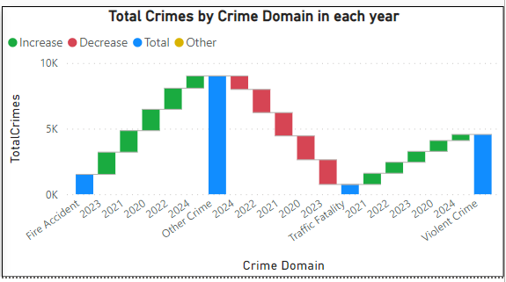
Visual Type: Waterfall Chart

Description: This chart illustrates the yearly progression of total crimes by domain, showing increases, decreases, and the net total for each year within each crime domain.

Key Findings: Violent crimes demonstrate a steady increase over the years, while traffic fatalities and fire accidents show consistent declines. "Other crimes" experienced a sharp peak in 2022, followed by a significant decrease in 2024, indicating improvements in mitigation efforts or changes in reporting trends.

  - What is the distribution of total crimes across different domains, and how does the case closure rate vary within each domain?

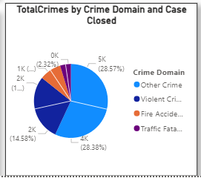
Visual Type: Pie Chart

Description: This chart represents the proportion of total crimes by crime domain and their respective case closure status, offering insights into which domains are more effectively managed.

Key Findings: "Other Crimes" and "Violent Crimes" collectively account for over 56% of total crimes, with relatively low case closure rates. Fire accidents and traffic fatalities, while smaller in volume, show higher resolution rates, suggesting more straightforward investigation processes.

- What are the temporal trends and seasonal patterns in crime occurrences across different domains and cities, and how do police deployments and case closures vary over time?
  - How have total crime occurrences varied over the years across different crime domains?

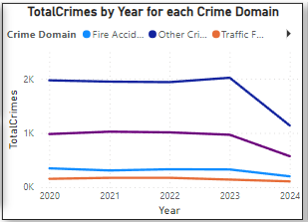
Visual Type: Line Chart
Description: This chart tracks the yearly trend in total crimes for each crime domain, illustrating changes in crime volume over time for Fire Accidents, Other Crimes, and Traffic Fatalities.
Key Findings: "Other Crimes" consistently reported the highest numbers but showed a significant decline in 2024. Fire accidents and traffic fatalities remained low throughout the years, with slight reductions observed, indicating effective management in these areas.
  - What is the annual trend in total reported crimes over the years?
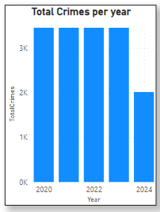
Visual Type: Column Chart
Description: This chart displays the total number of crimes reported annually from 2020 to 2024, providing a clear comparison of crime trends over the years.
Key Findings: Total crimes remained steady at around 3,500 from 2020 to 2023, but there was a significant drop in 2024, with the total falling to approximately 2,000, suggesting improved crime prevention or reporting changes.
  - What is the relationship between the total police deployed and the crime code count across different crime domains?
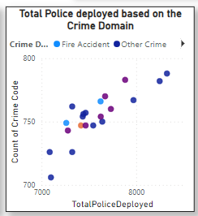
Visual Type: Scatter Plot
Description: This scatter plot depicts the relationship between the total police deployed and the count of crime cases across various crime domains, such as Fire Accidents and Other Crimes.
Key Findings: There is a visible positive correlation between the number of police deployed and the count of crime cases. Domains like "Other Crimes" consistently receive higher police deployment, indicating prioritization of resources toward these areas. However, some domains with fewer cases might require reallocation for efficiency.

  - Which cities have the highest and lowest number of cases closed, and how do they compare across all reported cities?
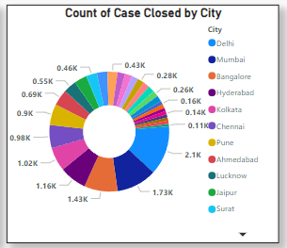
Visual Type: Donut Chart
Description: This chart represents the count of cases closed across various cities, providing a comparative view of case closure performance by location.
Key Findings: Cities like Pune, Ahmedabad, and Bangalore have the highest number of cases closed, with over 2,000 closures in Pune. Smaller cities like Jaipur and Surat report significantly fewer closures, suggesting disparities in case resolution efficiency or the volume of crimes reported.
  - How have different crime descriptions trended over the years, and which categories show significant increases or decreases?
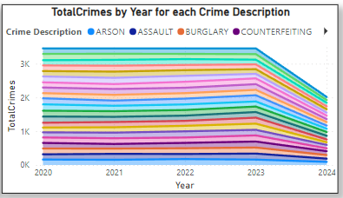
Visual Type: Stacked Area Chart
Description: This chart depicts the total number of crimes over the years for various crime descriptions, illustrating their contribution to the overall crime trend.
Key Findings: Crime descriptions like assault, burglary, and counterfeiting consistently contribute significantly to the total crime count. While overall crime numbers remained stable from 2020 to 2023, a notable decline is observed across all descriptions in 2024, suggesting improved crime prevention or reporting.
- How do victim demographics, such as age and gender, correlate with crime types and case resolutions?
  - What is the age distribution of victims for each crime type, and how does it vary across different crime descriptions?
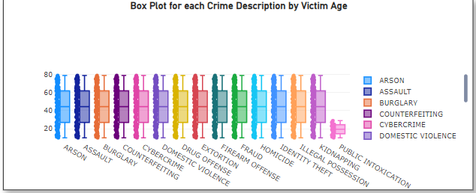
Visual Type: Box Plot
Description: This box plot visualizes the distribution of victim ages across various crime descriptions, highlighting the age range and central tendencies for each crime type.
Key Findings: Most crime descriptions show a wide age range of victims, with a median victim age consistently falling between 30 and 50. Domestic violence and cybercrime demonstrate narrower age distributions, while crimes like kidnapping and public intoxication show concentration in younger age groups. This suggests targeted prevention and support efforts are needed for specific age brackets.
  - What is the distribution of crimes across different victim age groups, and which age group experiences the highest crime incidence?
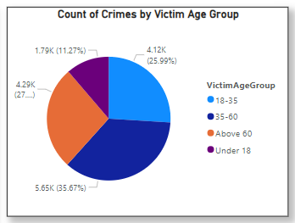
Visual Type: Pie Chart
Description: This chart shows the distribution of crimes by victim age group, highlighting the percentage contribution of each group to the total crime count.
Key Findings: Victims aged 35-60 account for the largest proportion of crimes (35.67%), followed by the 18-35 age group (25.99%). Victims under 18 and above 60 represent smaller shares, at 11.27% and 27%, respectively, indicating middle-aged adults are the most vulnerable demographic across all crime domains.
  - How does the number of closed cases vary across different victim age groups, and which group has the highest case resolution rate?
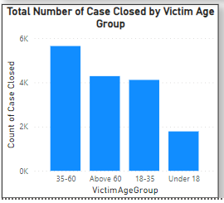
Visual Type: Bar Chart
Description: This chart displays the total number of cases closed, categorized by the victim's age group, providing insights into the resolution trends for different demographics.
Key Findings: Cases involving victims aged 35-60 have the highest closure rate (approximately 6K), followed by those in the "Above 60" and "18-35" age groups. Cases involving victims under 18 have the lowest closure rate, indicating potential challenges in resolving crimes affecting younger victims.
  - How do total reported cases vary by age groups across different crime domains, and which domain has the highest occurrence for each age group?
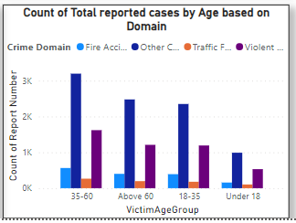
Visual Type: Clustered Bar Chart
Description: This chart presents the count of total reported cases by victim age group across different crime domains, offering a comparative view of how each domain impacts specific age groups.
Key Findings: Victims aged 35-60 report the highest number of cases across all domains, particularly in "Other Crimes" and "Violent Crimes." Victims under 18 report the fewest cases, with most incidents falling under "Violent Crimes" and "Traffic Fatalities," highlighting targeted vulnerabilities for younger victims.
- How efficiently are police resources being deployed across different crime domains, and how does this impact case closure rates and time to resolution?
  - How does the allocation of police resources vary by victim gender across different crime domains?
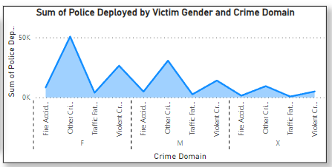
Visual Type: Area Chart
Description: This chart represents the total police deployment segmented by victim gender and crime domain, highlighting resource allocation patterns across gender-specific crime domains.
Key Findings: The highest police deployment is observed in "Other Crimes" involving female victims, followed by "Violent Crimes" and "Fire Accidents." Deployment for male and gender-unspecified ("X") victims is relatively consistent across domains, suggesting resource prioritization for crimes affecting women.
  - How are police resources allocated across different crime domains?
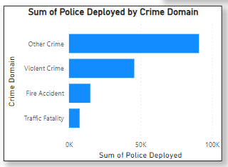
Visual Type: Bar Chart
Description: This chart displays the total police deployment across different crime domains, providing insights into resource allocation priorities.
Key Findings: Most police resources are allocated to "Other Crimes," followed by "Violent Crimes." Significantly fewer resources are deployed for "Fire Accidents" and "Traffic Fatalities," suggesting a focus on domains with higher complexity or volume.

Conclusions and Recommendations
Conclusions
Analysis of the crime data yields important information on victim demographics, resource allocation, and crime trends. The report's main findings include:
- Crime Trends:
  - Crime rates was constant from 2020 and 2023 but fell precipitously in 2024, possibly because of enhanced security or modifications to reporting procedures.
  - With the bulk of cases in every year, "Other Crimes" and "Violent Crimes" dominate the criminal scene.
- Resolution of Cases:
- The 50% total case closure rate shows inefficiencies in getting issues resolved quickly.
- The lowest closure rates are found in cases with victims under the age of 18, underscoring the difficulties in prosecuting crimes against younger victims.
- Allocation of Resources:
- While "Traffic Fatalities" and "Fire Accidents" receive little attention, "Other Crimes" and "Violent Crimes" receive a significant portion of police resources.
- In comparison to lesser cities, cities such as Pune, Ahmedabad, and Bangalore have greater case closure counts, indicating superior law enforcement efficacy.
- Victims' demographics:
- The most afflicted age group is victims between the ages of 35 and 60, followed by those between the ages of 18 and 35.
- When allocating resources, female victims are given preference, especially in areas like "Other Crimes."
- Temporal Trends:
- June, July, and December are among the months with the highest crime rates, revealing seasonal patterns that call for careful planning.
Recommendations:
The following suggestions are made considering the findings:
- Improve the Effectiveness of Case Resolution:
- To increase case closure rates, especially for crimes involving younger victims, invest in cutting-edge investigative equipment and training.
- Put performance monitoring into place for law enforcement organisations to find and fix case resolution bottlenecks.
- Maximize Allocation of Resources:
- To guarantee fair attention to areas like "Traffic Fatalities" and "Fire Accidents," which presently receive lower resources, reevaluate how police resources are allocated.
- While giving underperforming smaller cities more assistance, give deployment priority to high-crime areas like Delhi, Mumbai, and Bangalore.
- Protection of Specific Victims:
- Create victim support services aimed at the most impacted age groups, which include those between the ages of 18 and 35 and 35 and 60.
- Implement targeted awareness efforts and safety programs to strengthen preventive measures for younger groups and female victims.
- Take Seasonal Trends into Account:
- To lessen the expected increase in criminal activity, allocate more resources during the months of June, July, and December, when crime is at its highest.
- During these times, start preventive initiatives to increase public awareness and discourage possible criminal activity.
- Make Use of Data Analytics and Technology:
- To find new crime hotspots and predict future trends, use predictive analytics.
- Utilize data-driven insights to keep an eye on and modify crime prevention tactics over time.
- Awareness and Involvement in the Community:
- To increase cooperation and trust between local communities and law enforcement, step up community policing initiatives.
- Run crime prevention education initiatives, especially for high-risk populations and localities.
Stakeholders can increase public safety, maximize resource use, and boost the general efficacy of law enforcement operations by putting these suggestions into practice.
PERSONAL CONCLUSION
The report identifies crime hotspots, prevalent crime types, victim demographics, and resource allocation patterns. The following are the primary suggestions:
- Increase the deployment of police officers in high-crime areas, with a particular emphasis on cities with high property crime rates, as identified in the geographic crime analysis.
- Enhance Resource Allocation: By reallocating police resources to enhance closure rates, concentrate on crime domains with high case backlogs, such as property offences.
- Implement targeted community safety initiatives: Particularly for females and younger individuals, who are classified as higher-risk demographics.
- Plans for Seasonal Preparedness: Identify seasonal patterns in crime and allocate resources accordingly during prime crime months to prevent incidents.
- By aligning resources with high-risk areas, vulnerable demographics, and crime patterns, the insights in this report empower law enforcement and policymakers to adopt a more strategic approach to crime prevention.

SECTION 2: BUSINESS INTELLIGENCE DESIGN

Data preprocessing or Data Cleansing
Below are the steps taken to prepare and clean the data for analysis in Power BI:
Steps Performed:
- Error Removal:
When the data was loaded from the excel sheet there was an error in the “date of Occurrence” column
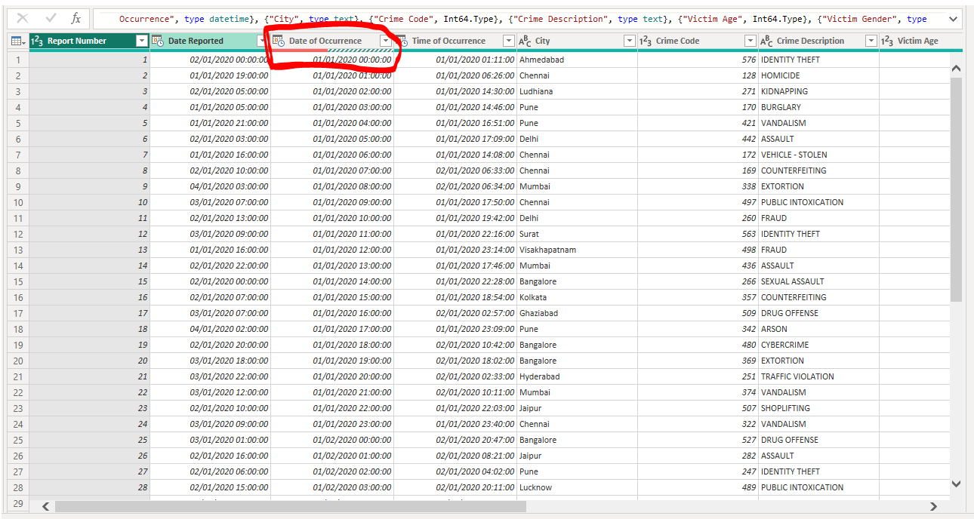
Error Message:
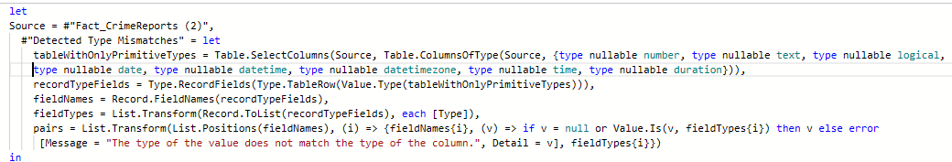
The error occurred because the column "Date of Occurrence" was set to the Date data type, but some values included a time component (e.g., 00:00), causing a type mismatch.
Resolving the Error:
- Right clicked on the "Date of Occurrence" column in the Power Query Editor.
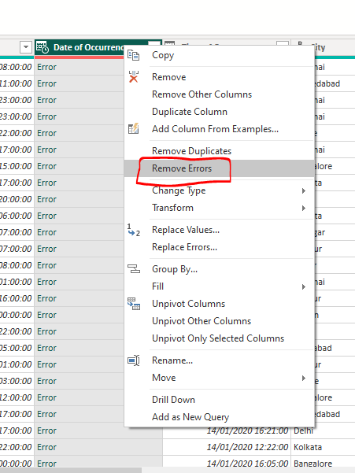
- Selected the "Remove Errors" option from the context menu.
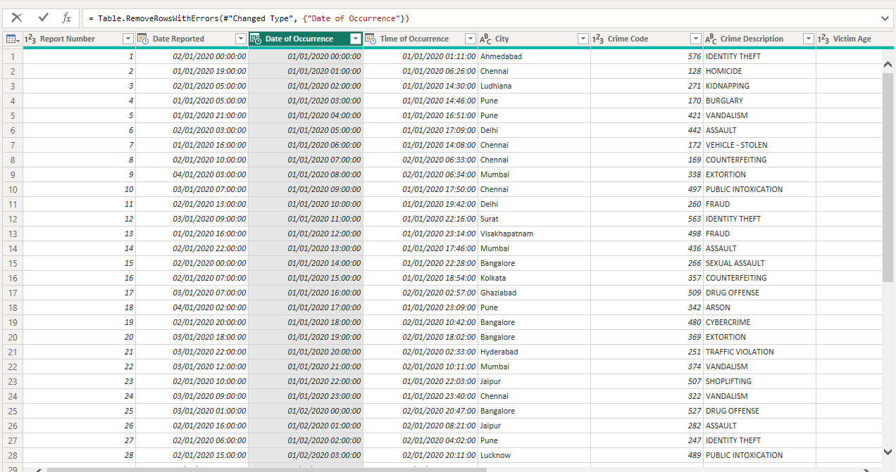
- This action automatically removed all rows containing invalid data that caused the type mismatch.
- The remaining rows adhered strictly to the Date data type, ensuring consistency and resolving the error.
- Remove Duplicates:
The column "Report Number" served as the primary key for the table, so it was essential to ensure that it contained unique values. To achieve this, the following steps were performed:
- Right clicked on the "Report Number" column in the Power Query Editor.
- Selected the "Remove Duplicates" option from the context menu.
- This action automatically removed any duplicate values from the column, ensuring that the data was clean and that the "Report Number" column maintained its uniqueness as the primary key.
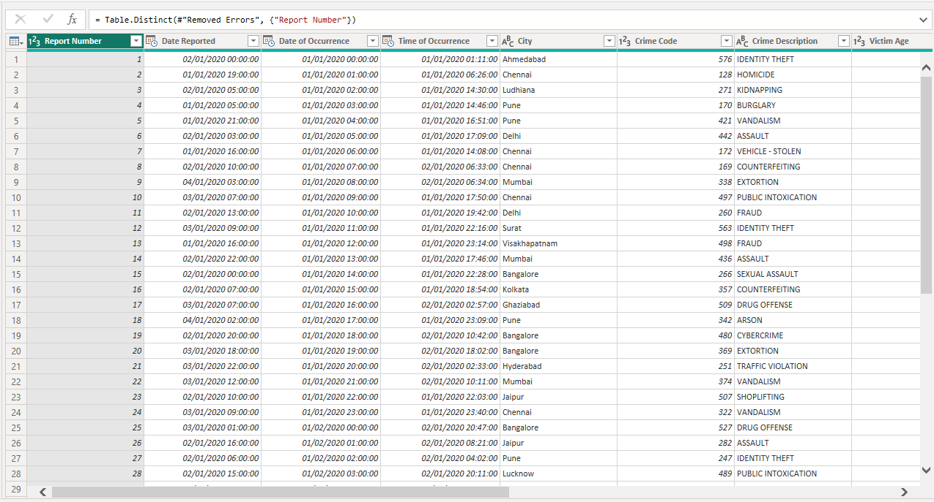
- Handling Missing Values:
- Rows with missing values in "Report Number" (the primary key) were removed, as this column must contain unique identifiers for the records.
- For "Date Reported", any rows with missing dates were deleted since a valid reporting date is crucial for temporal analysis.
- Null values in "City" were removed as this information is essential for geographic analysis.
- Rows missing "Crime Code" were removed because this column is required to classify crimes correctly.
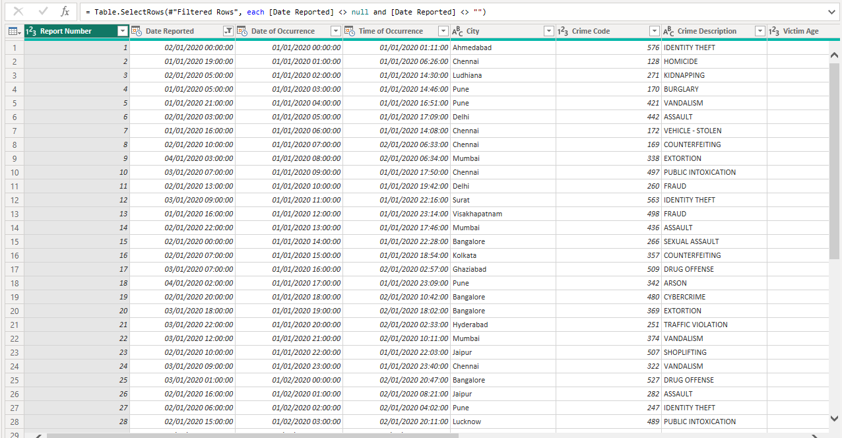
- Data Type Corrections:
Columns such as "Date Reported", "Date of Occurrence", and "Date Case Closed" were identified as requiring a Date data type for time-based analysis.
In the Power Query Editor:
- Right clicked on each date column (e.g., "Date Reported").
- Selected "Change Type" and then "Date" from the dropdown menu.
This ensured the column values were treated as pure dates without any time component.
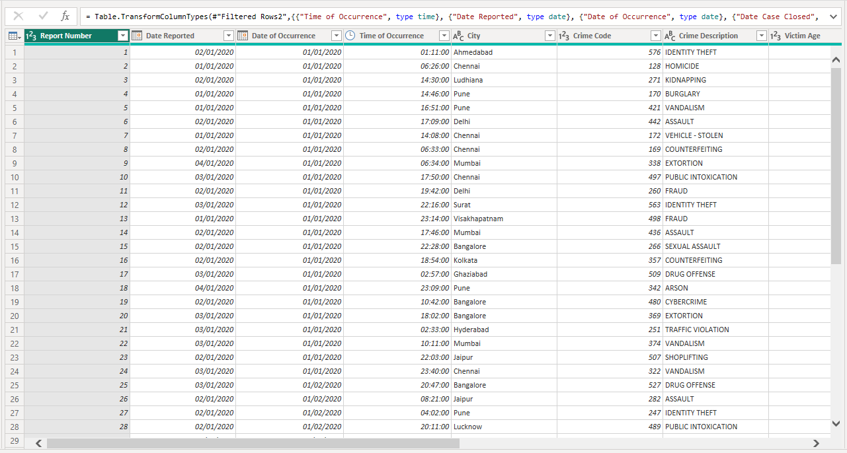

BI Data Modelling via Star Schema – Facts and Dimensions.
The above cleaned table was considered as the fact table. From that fact table, weare dividing into dimension tables named as below:
- CrimeDetails Table
- VictimDetails Table
- CaseStatus Table
- MasterCrimeReports Table

- CrimeDetails Table:
This table contains the crime data like the crime domain and description. The table contains the following columns:
- ReportNumber (Primary Key)
- Crime Code
- Crime Description
- Crime Domain
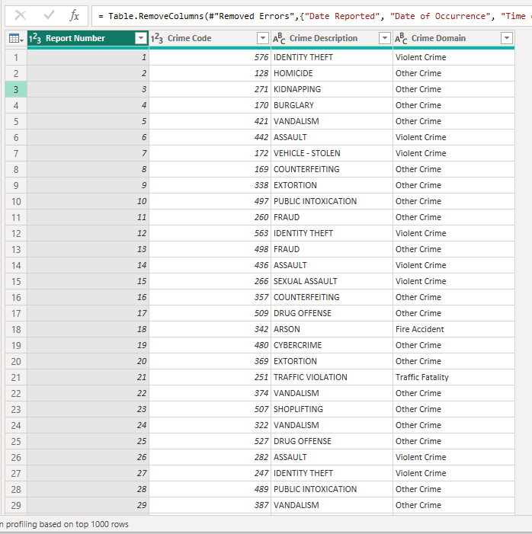
- VictimDetails Table:
This table was derived from the main fact table. This table contains the details of the victims holding the below mentioned columns:
- Report Number (Primary Key)
- Victim Age
- Victim Gender
- Crime Domain
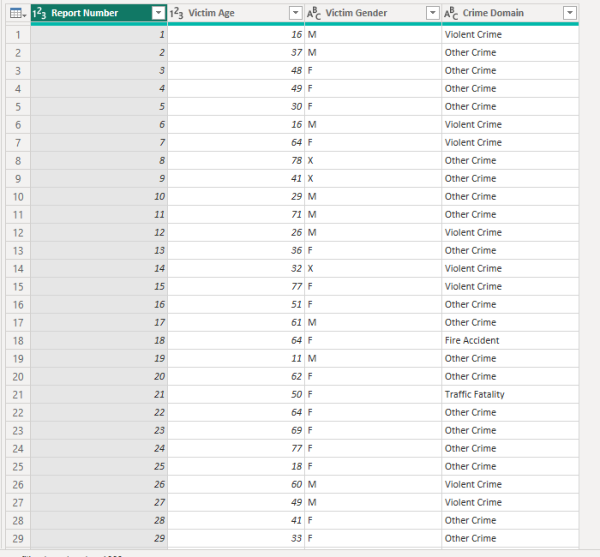
- CaseStatus Table:
This table contains the details of the case status like when the case was reported, and case closed. The columns in the CaseStatus table are as below:
- Date Case Closed
- Case Closed (custom column created using the DAX formula)
- Police Deployed
- Report Number (Primary Key)
- Date Reported
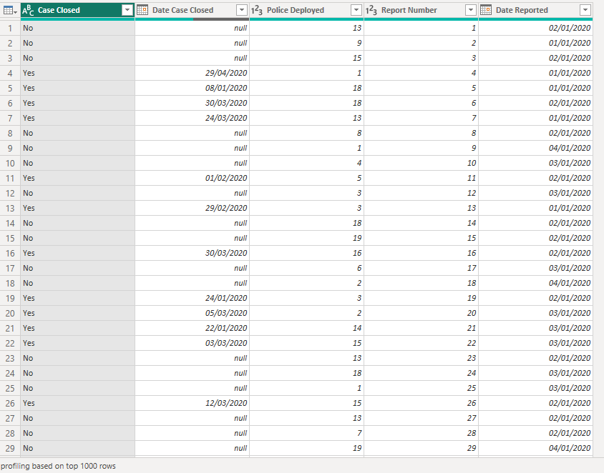
- MasterCrimeReports Table:
This table contains all the required and essential details of the case holding the below mentioned column data:
- Report Number (Primary Key)
- Date Reported
- Date of Occurrence
- Time of Occurrence
- Crime Code
- Weapon Used
- Crime Domain
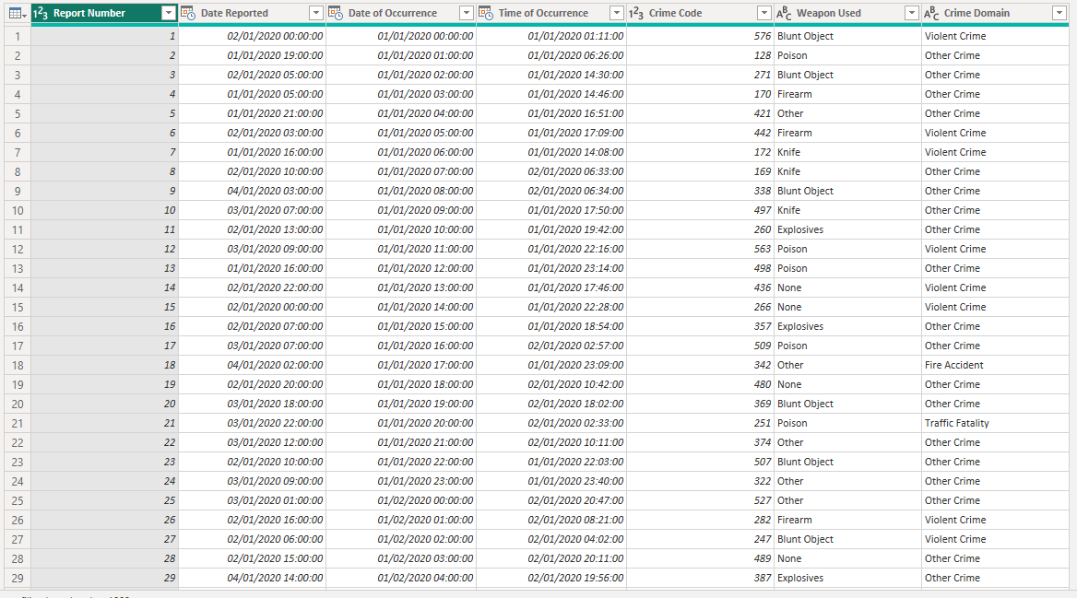

STAR SCHEMA:
By using the primary key, we have implemented one – one (1:1) relationships for all the tables.
Before star Schema:
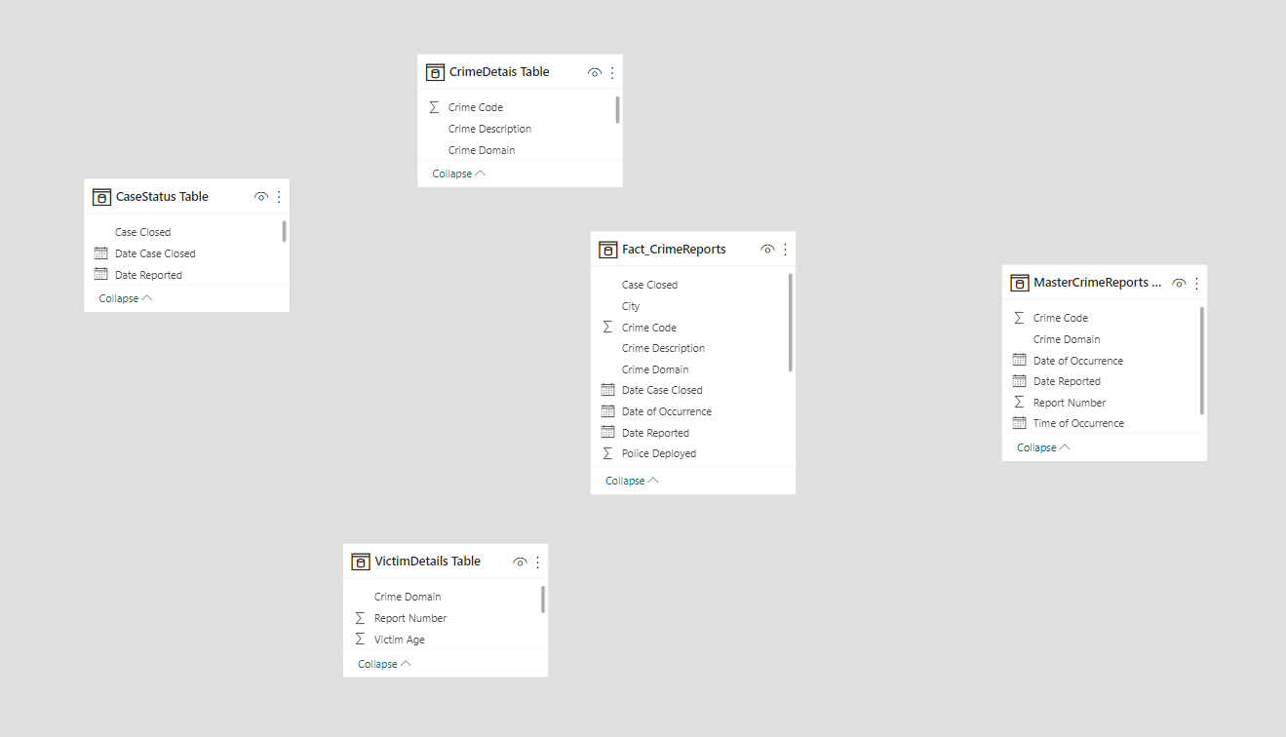
After implementing star schema:
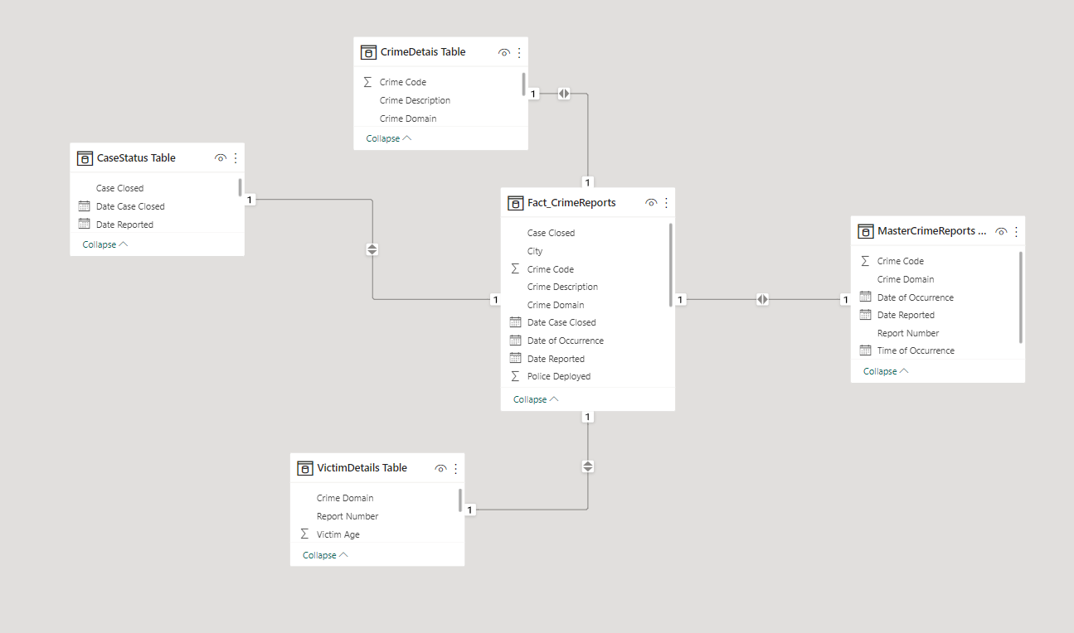

DAX Functions and Calculated Columns
DAX Functions:
- Average days to close the case:
AvgDaysToClose =
AVERAGEX(FILTER('CaseStatus Table', 'CaseStatus Table'[Case Closed] = "Yes"), 'CaseStatus Table'[DaysDifference])
Description:
This function provides insight into the efficiency of case resolution by determining the average time (in days) taken to close successfully resolved cases.
- Percentage of case closed:
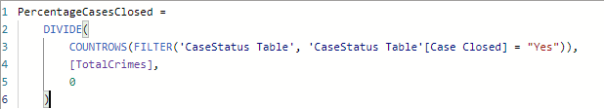
Description:
This function calculates the proportion of closed cases relative to the total number of crimes, providing a metric for the resolution rate of reported crimes.
- Total Police Deployed:
TotalPoliceDeployed = SUM('CaseStatus Table'[Police Deployed])
Description:
This measure computes the total number of police personnel deployed across all cases, providing an aggregated view of resource allocation.
- Total Crimes:
TotalCrimes = COUNTROWS('MasterCrimeReports Table')
Description:
This measure provides the total number of crimes recorded in the dataset, serving as a key metric to analyze crime volume.
- Average police deployed:
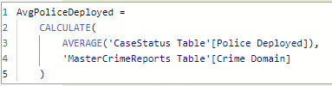
Description:
This measure determines the average number of police resources allocated for each specific crime domain, providing insights into resource allocation trends for different types of crimes.
- Average Victim age by crime:
AvgVictimAgByCrime = AVERAGE('VictimDetails Table'[Victim Age])

Description:
This measure provides insights into the typical age of victims involved in crimes, helping to identify demographic patterns and trends related to victim age across various crimes.
- Case Closed Rate:
CaseClosedRate = DIVIDE(COUNTROWS(FILTER('CaseStatus Table','CaseStatus Table'[Case Closed] = "Yes")),COUNTROWS('MasterCrimeReports Table'))
Description:
This measure provides a case closure rate, a key metric to evaluate the efficiency of case resolutions. It highlights how effectively crimes are being resolved relative to the total number of crimes reported.
- Gender Ratio Violent Crimes:
GenderRatioViolentCrimes = DIVIDE(COUNTROWS(FILTER('VictimDetails Table', 'VictimDetails Table'[Victim Gender] = "Male" && 'VictimDetails Table'[Crime Domain] = "Violent")), COUNTROWS(FILTER('VictimDetails Table', 'VictimDetails Table'[Crime Domain] = "Violent")))
Description:
This measure provides the gender ratio for male victims in violent crimes, enabling an understanding of male victim representation in such crimes. It can be used to highlight gender-specific trends in violent crimes for further analysis.
- Victim Age Group:
VictimAgeGroupProp =
DIVIDE(
COUNTROWS(FILTER('VictimDetails Table', 'VictimDetails Table'[Victim Age] < 18)),
[TotalCrimes], 0
)
Description:
This measure calculates the proportion of victims under 18 years old out of the total number of crimes. It provides an understanding of the representation of minors in the crime dataset, which can help identify patterns or prioritize resources for this demographic.
CALCULATED COLUMNS:
- Days Difference Column in CaseStatus Table:
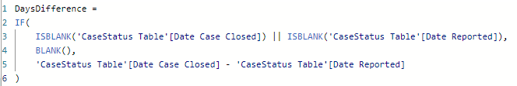
The DaysDifference calculated column is designed to compute the number of days between the Date Reported and the Date Case Closed for cases in the CaseStatus Table. Here's a detailed explanation:
Formula Breakdown:
IF Condition:
- The formula checks if either Date Case Closed or Date Reported is blank using the ISBLANK function.
- If either of these fields is blank, the formula returns BLANK() for that row, ensuring that incomplete data does not result in an invalid calculation.
Subtraction:
- If both Date Case Closed and Date Reported are available, the formula calculates the difference between the two dates:
- 'CaseStatus Table'[Date Case Closed] - 'CaseStatus Table'[Date Reported].
- This provides the total number of days taken to close the case.
Result:
- The column contains the number of days it took to close a case for each row in the table where both dates are present.
- If the dates are missing, the result is BLANK().
Purpose:
This calculated column is used to analyze the time taken to close cases. It helps in generating insights such as:

- Average days to close cases.
- Patterns or trends in case closure times.
- Identification of outliers in case resolution periods.
This metric is particularly useful for evaluating the efficiency of the case resolution process.
- Victim Age Group column in VictimDetails Table:
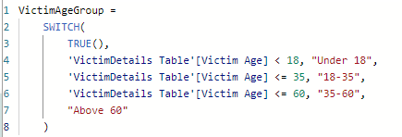
The VictimAgeGroup calculated column is used to categorize victims into specific age groups within the VictimDetails Table. Here's a detailed explanation:

Formula Breakdown:
- SWITCH(TRUE(), ...):
- The SWITCH(TRUE(), ...) construct is used to evaluate multiple conditions in sequence.
- It allows for dynamically assigning a value (age group) based on the age of the victim.
- Conditions:

- 'VictimDetails Table'[Victim Age] < 18, "Under 18":
  - If the victim's age is less than 18, the age group is labeled "Under 18".
- 'VictimDetails Table'[Victim Age] <= 35, "18-35":
  - If the victim's age is between 18 and 35 (inclusive), the age group is labeled "18-35".
- 'VictimDetails Table'[Victim Age] <= 60, "35-60":
  - If the victim's age is between 36 and 60 (inclusive), the age group is labeled "35-60".
- Default ("Above 60"):
  - If none of the above conditions are met, the age group is labeled "Above 60".
- Result:
- This column contains the categorized age group for each victim based on their age.
Purpose:
The VictimAgeGroup column is essential for:
- Grouping and analyzing victims by age demographics.
- Studying trends and patterns in crimes based on victim age.
- Supporting visualizations, such as pie charts or bar graphs, to highlight the distribution of victims across different age groups.
This calculated column provides an effective way to segment data and extract meaningful insights related to victim age demographics.

Dashboards

Welcome Dashboard
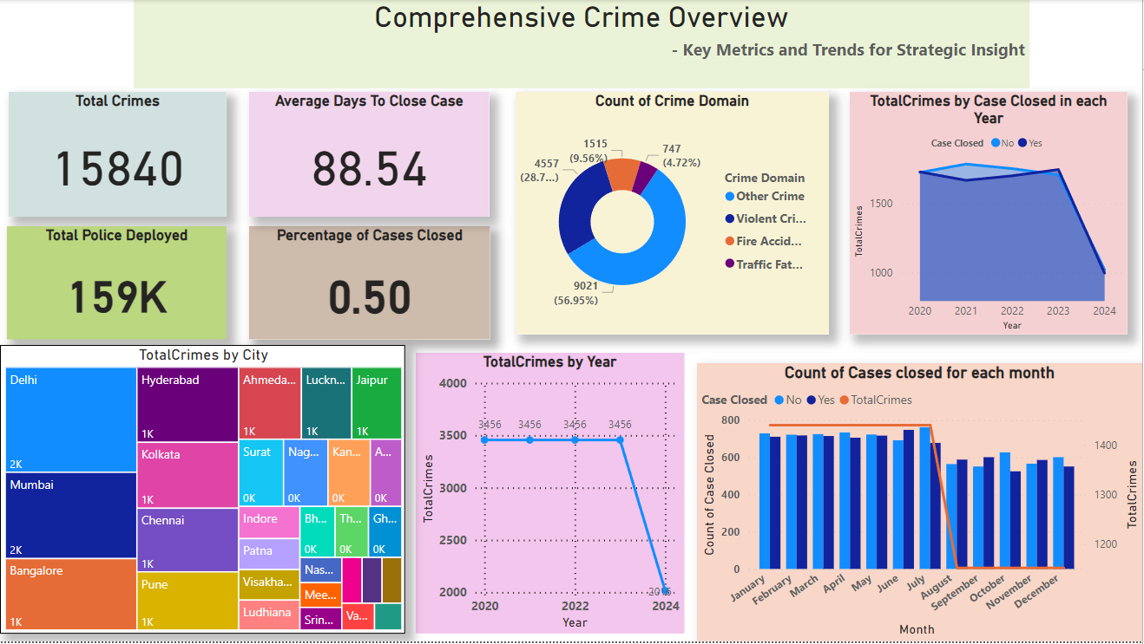
This dashboard page provides a high-level summary of the overall crime trends and key metrics, offering insights into the scope, resolution, and resource allocation of reported crimes. It is structured to give both quantitative and visual representations for quick comprehension.
- To provide a comprehensive overview of total crimes, resource allocation, and case resolution efficiency.
- To identify the distribution of crimes across domains and highlight the most prevalent crime types.
- To analyze trends in crime reports and case closures across years and months.
- To visualize geographical hotspots for crimes by city.
- To serve as a foundation for strategic decision-making and resource prioritization in law enforcement.

Crime Analysis by Type
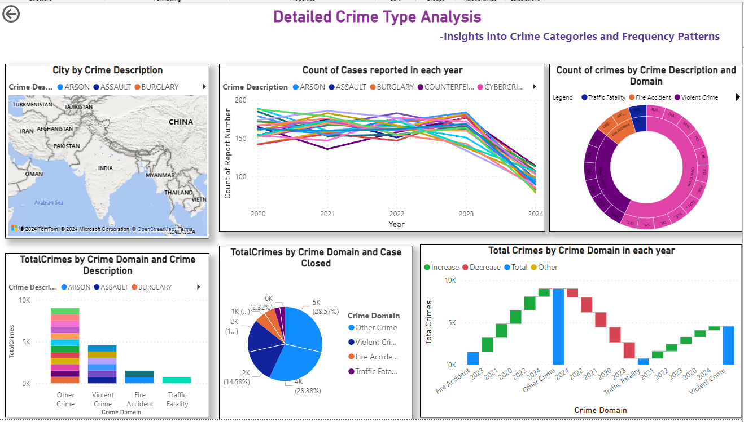
- To provide detailed insights into the frequency and distribution of various crime types across regions and time.
- To analyze yearly trends for specific crime descriptions and track fluctuations over time.
- To understand the relationship between crime domains and their case closure statuses.
- To visualize crime categories geographically for targeted interventions.
- To explore how crime patterns evolve, offering a deeper understanding for policy and resource allocation.

Crime Trends Over Time
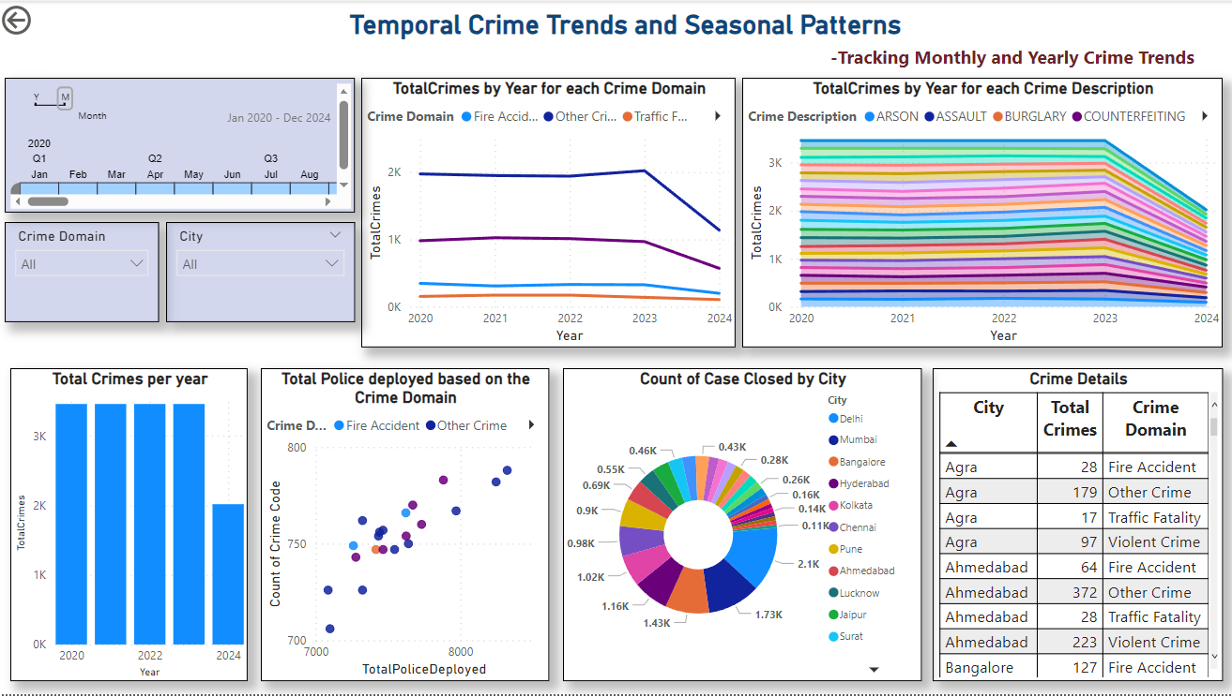
- To identify temporal trends in crimes, showcasing yearly and monthly fluctuations for better resource allocation.
- To analyze the deployment of police forces based on crime domains and assess the efficiency of law enforcement responses.
- To track case closure rates by city, offering insights into regional crime management performance.
- To examine crime distributions across cities and domains for targeted prevention and intervention strategies.
- To provide detailed crime data at a city and domain level, enabling granular decision-making and planning.

Victim Demographics
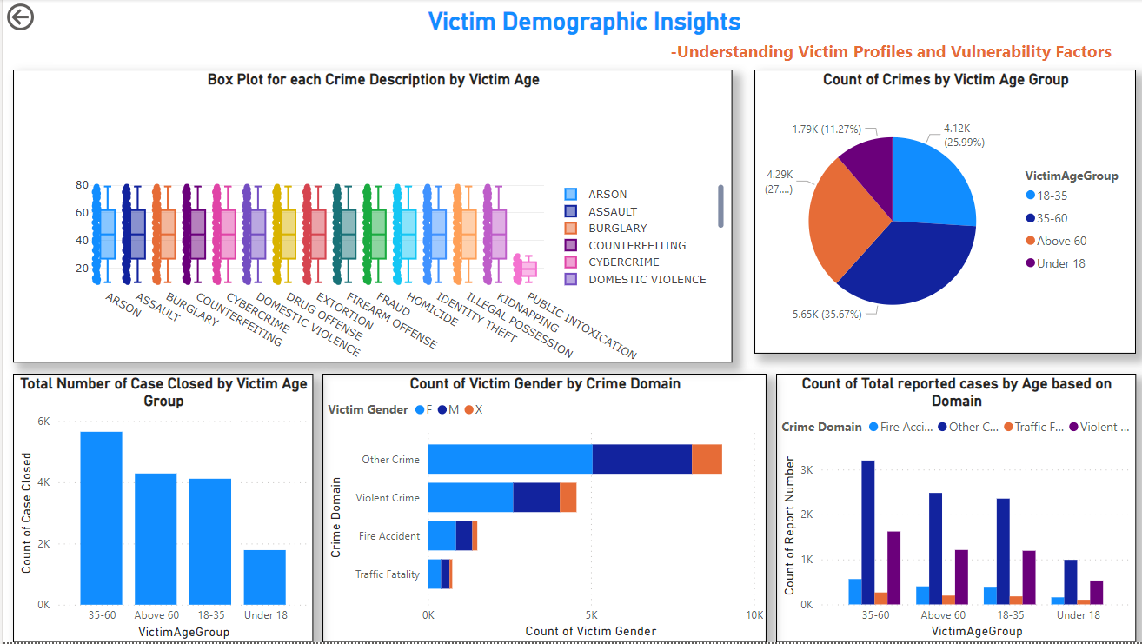
- To analyze victim demographics by age and crime description, highlighting vulnerability trends among different age groups.
- To provide a detailed distribution of crimes by age groups, helping to identify high-risk categories.
- To compare case closure rates across age groups, indicating efficiency in addressing crimes involving various demographics.
- To examine gender-based victimization across different crime domains, uncovering gender-specific vulnerabilities.
- To explore reported cases by age and crime domain, offering insights into patterns and preventive strategies.

Case Status and Police Response
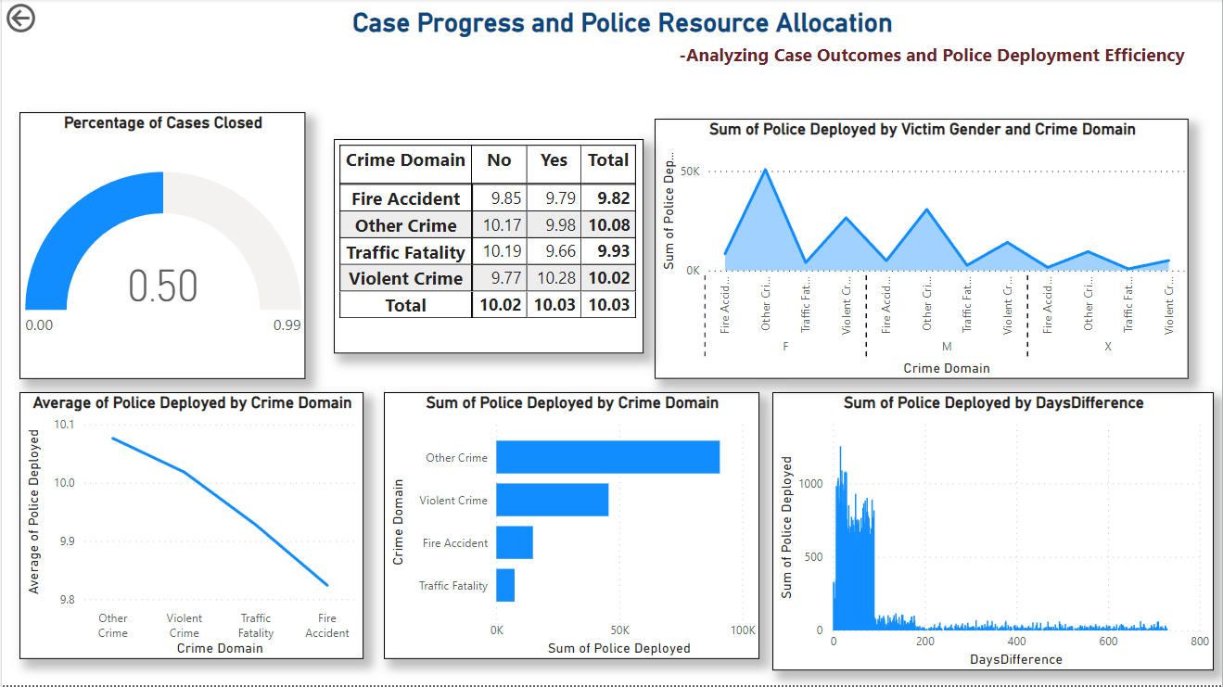
- To evaluate the progress of crime cases and assess the effectiveness of case closure rates across different crime domains.
- To analyze police deployment patterns and their correlation with crime domains, providing insights into resource allocation.
- To investigate how police deployment varies by victim gender and crime domain, highlighting disparities or focused efforts.
- To examine the relationship between the days taken to close cases and the total police resources allocated.
- To provide an overview of average and total police deployment for different crime domains, aiding in operational planning.

